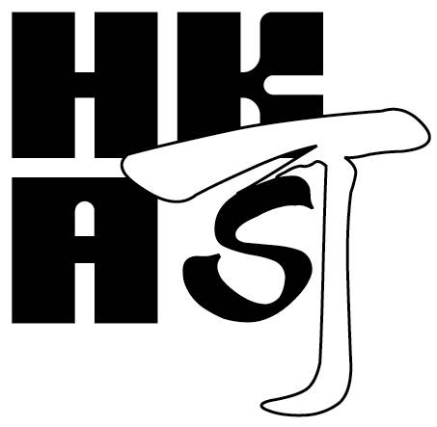
PC02

HKCAS WITNESS ASSESSMENT REPORT
(PRODUCT CERTIFICATION)

 | Name of certification body: |  |  | Case ID:
 | Type of audit:
 | Date(s) of audit:
 | Name and location of audited organisation:
 | Product certification scheme:
 | Product(s) covered:
 | Audit team leader:
 | Audit team member(s):
 | Independence, impartiality and integrity :
[Items to be considered:
- Over-familiarity with the auditee(s)
- Reaction to intimidation
- Explanation of CB’s policy on integrity

 | Planning and preparation:
[Items to be considered:
- Time allocation; team composition
- Preparation of the audit team: studying received documents; preparation of the audit plan; focus on the certified products]

 | Opening meeting:
[Items to be considered:
- Clarification of roles and responsibilities; confidentiality matters; audit criteria; audit process; reporting]

Conduct of the audit:
[Items to be considered:
- Adher
- elevant auditing procedures
- Checking production processes, IQC/IPQC/OQC processes, equipment and staff training as appropriate
- ll management system requirements prescribed in the scheme
Witnessing of tests, verification of records and examination of products the requirements.]

Technical competence of the audit team:
[Items to be considered:
- Familiar with the certification requirements including the relevant product requirements
- Familiar with the critical materials/components, design and features of the certified product(s)
- Familiar with the production and QA/QC processes relevant to fulfillment of certification requirements]

Audit report and closing meeting:
[Items to be considered:
- Audit findings are properly recorded
- Findings and conclusion of the audit as well as the consequences are presented to the client clearly and concisely, both orally and in writing
Overall performance:
[Items to be considered:
- Coverage and depth of audit; focus on the certified products; ensuring conformity with the certification requirements
- The attitude and skill of auditors; conform to certification body’s policy and requirements
- Identification of key issues related to the certified products by the audit team]

The overall performance of the audit is considered to be acceptable / not acceptable.

Name and signature of assessment team leader:
Name and signature of assessment team member:
End of Report

